# Directions

1. Complete the following steps.
2. Screenshot where directed.
3. Submit to Blackboard.

# Selenium Theory

1. What data type does findElement return? 1 point

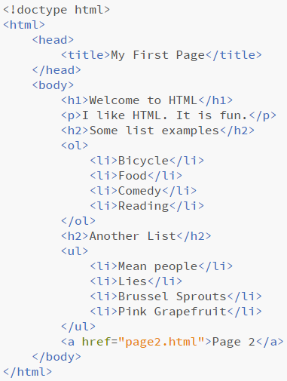**It should, in theory, return a single WebElement object. One would think.**

1. What data type does findElements return? 1 point

**In theory, I would expect it to return a list of WebElement objects.**

1. List five different ways that findElement can locate objects on a web page. 5 points

**ID, Name, Class Name, Tag Name, XPATH, and using text.**

1. Given this simple web page, write the following XPath queries. 3 points
   1. Absolute path to the first li in the ul

**Html/body/ul/li[1]**

* 1. Absolute path to the a tag

**Html/body/a**

* 1. Predicate path to the second h2

**Html/body/h2[2]**

# Selenium

Write the Java code to solve the following Selenium locator problems. Include the variable declaration and assignment statement holding the result of the query. The code does not need to compile.

***Code and Screenshots below.***

Use <http://cottrell.lee.stuweb.ptcollege.edu/carpetPostPersistent.php> to answer these questions

1. Connect the ChromeDriver to <http://cottrell.lee.stuweb.ptcollege.edu/carpetPostPersistent.php> 1 point

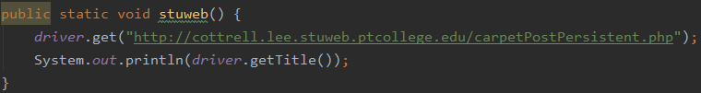

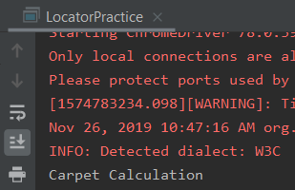

1. Build three web elements that connect to the three text boxes, by ID. 3 points

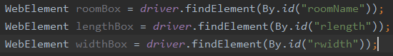

1. Write the java code that will return all of the buttons on the form. 1 point



1. Do the same query above using a different method. 1 point



Use <https://www.ptcollege.edu> to answer these questions

1. Connect the ChromeDriver to <https://www.ptcollege.edu> . 1 point

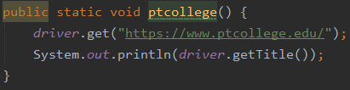

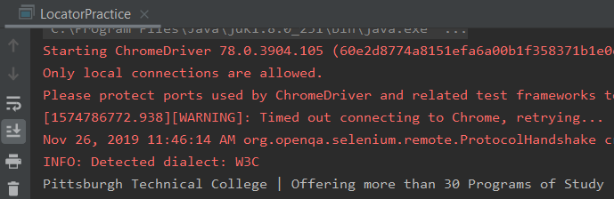

1. Find all links on the page. 1 point





(This list of links goes on forever… D:)

1. Find the link with the word Blackboard. 1 point

“Correct” Code:



1. Use an XPath selector to find the 5th link on the page. 1 point



